Web Quest
* Your answers will need to go on a separate sheet of lined paper.
* Be sure to number your answers according to the question.
* Click on the links above the questions to help activate your knowledge of rocks.

1. http://www.harcourtschool.com/activity/science_up_close/506/deploy/interface.swf
What story of Earth’s history can we gather from rocks and minerals?

2.http://archive.fossweb.com/modulesK2/PebblesSandandSilt/activities/findearthmaterials.swf
What would it be like if there was only 1 kind of rock? For example, we only had one kind of rock and it was the pumice rock. What effect would this have on Kennesaw Mountain? Explain.

3. https://www.learner.org/interactives/rockcycle/swfs/transform.swf
Explain how weathering the preparation for erosion?

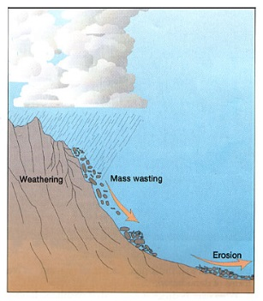
4. http://www.harcourtschool.com/activity/science_up_close/201/deploy/interface.swf
http://www.bbc.co.uk/schools/scienceclips/ages/7_8/rocks_soils_fs.shtml (take the quiz at the end to increase your knowledge on rocks)
You have learned that rocks have different types of textures, color, and hardness. If rocks were to compete with each other in a “Rock Bowl” who would win? Explain the physical properties you are comparing and who would WIN!
Pumice VS Granite
Slate VS Marble
Pumice VS Chalk
Granite VS Sandstone

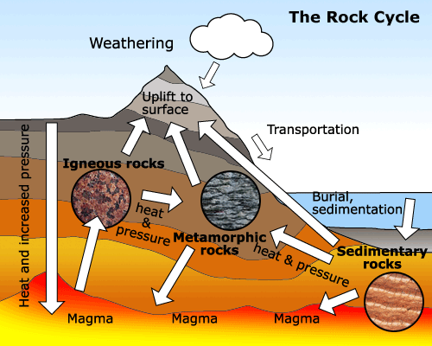

5. http://www.harcourtschool.com/activity/science_up_close/506/deploy/interface.swf
You are a famous geologist and just discovered a brand new rock! Now, you have to share your discoveries with the world. To begin, you need to determine HOW this new rock fits into the Rock Cycle.
How was it formed?
What are its properties?
Draw a picture of the rock and the Rock Cycle showing where it fits.

